**CLOUD REGISTRATION**

|  |  |
| --- | --- |
| Team Id | PNT2022TMID39958 |
| Project | AI-Powered Nutrition Analyzer for Fitness Enthusiasts |

**Name : Aswini.G**

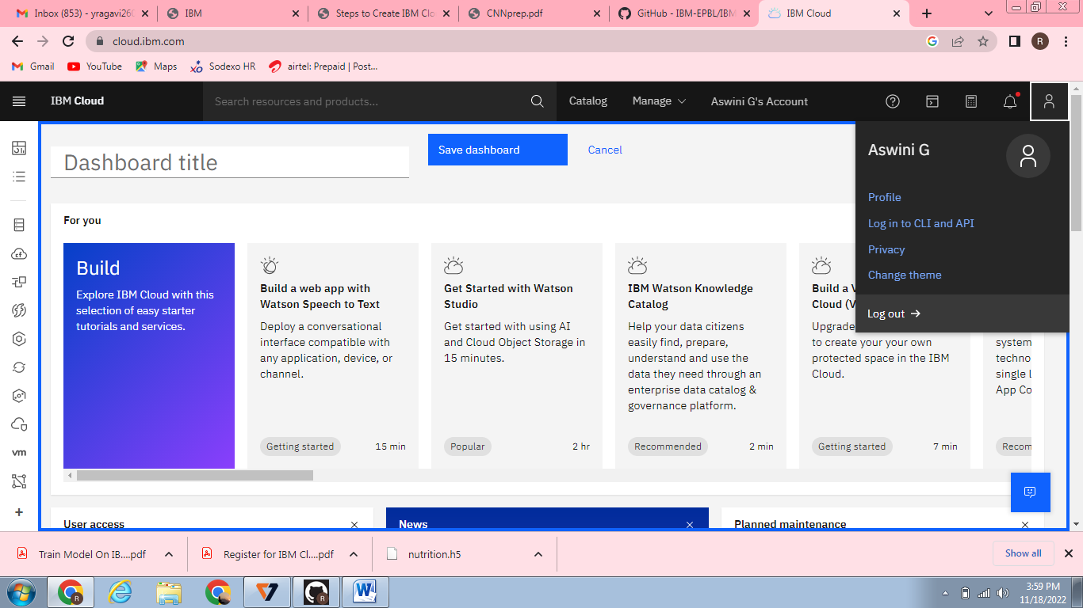

**Name: Jannani.K**

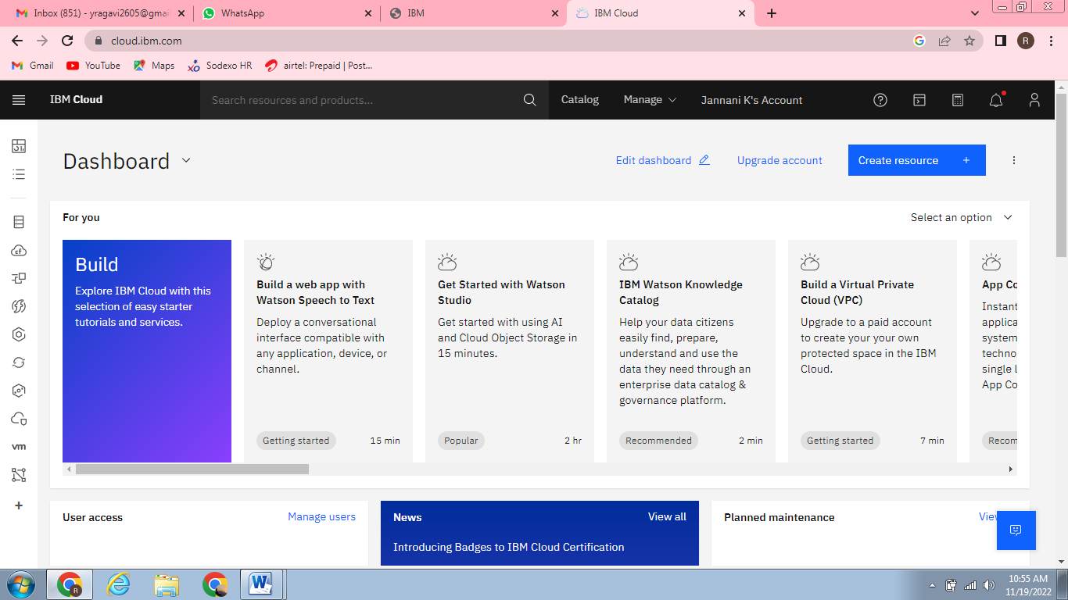

**Name: Sneha.P**

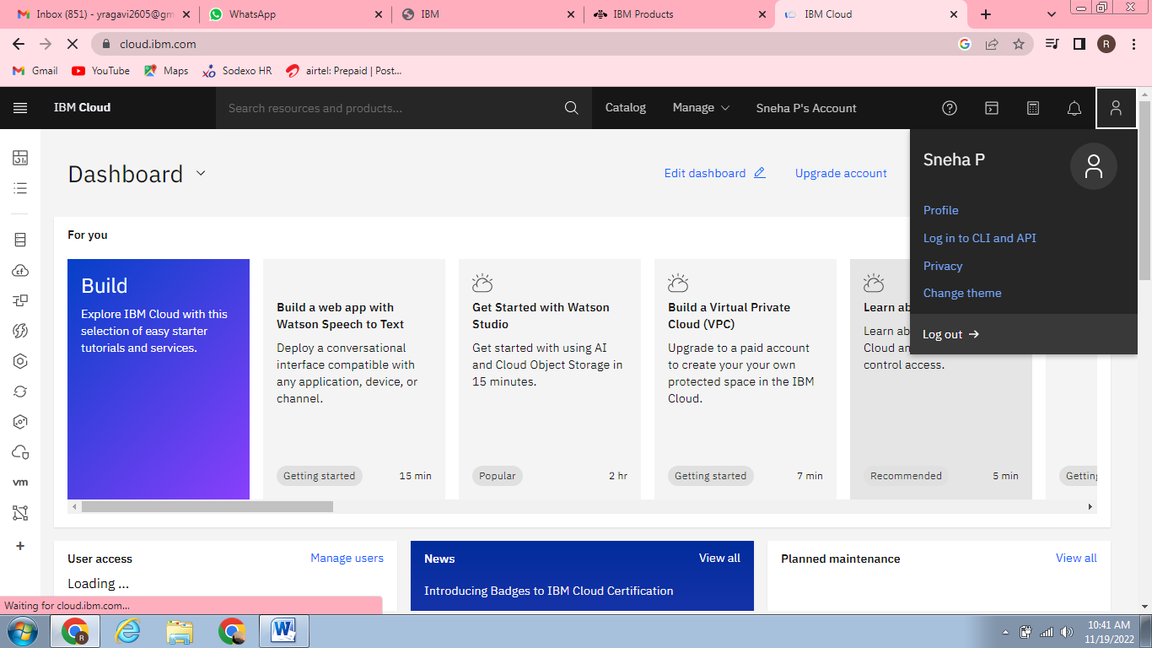

**Name: Ragavi.Y** 